ENHANCING CRITICAL THINKING THROUGH DEBATE TECHNIQUE

Hanafi Wibowo ¹,
*Universitas Islam As-Syafi’iyah, Jl. Jatiwaringin Raya no 12 PondokGede, Jakarta Timur, Indonesia, Email: hanafiwibowo.fkip@uia.ac.id
Zharifah Nasroh Azizah ²,
**Universitas Islam As-Syafi’iyah, Jl. Jatiwaringin Raya no 12 PondokGede, Jakarta Timur, Indonesia, Email: Azizahzharifah@yahoo.co.id

Abstract
This research based on the important of the student’s critical thinking for general students. Critical thinking is very important in daily life. Because , students are required to have the ability to choose and sort the information that is good and true. This research to identify how far debate can effect student’s critical thinking. This research was classroom action research it consist of two cycle, each cycle consist of three meetings. The data had been taken from each cycle then the average is compared. If there is an enhance in this research it means the research is successful. But if there is no enhance in this research it means the research is failed. This research is conducted in Islamic University Of Assyafi’iyah, It was located in Jatiwaringin street. This research was involved the first Semester English Education Study Program was consist of 34 college students and they were as subjects of this research. This research was considered successful by researchers because there was a significant improvement from cycle one to cycle two, which 62,87 to 70,37. The results of this research help teachers to enhance students’ critical thinking through debate technique.

Keywords : Critical Thinking, Debate Technique

Introduction
At this time critical thinking is very important in daily life, especially among college students and high school students need to enhancing their critical thinking. Sincestudents are required to have the ability to choose and sort the information that is good and true. According to the Surya ( 2011 )“ critical thinking is an active, persistent, and careful consideration of any belief or form of knowledge that is received in terms of various reasons that support and conclude” ( P.131 ). Johnson ( 2010 ) stated that“ critical thinking is an organized and clear process that is used in mental activities such as problem solving, decision making, analyzing assumptions, and scientific discovery” ( P.100). Critical thinking is the better thinking based on logical reason. Students are able to open minded, analyze the problems and find the background. Critical thinking can also conclude the relevant data. When making a decision or conclution using active control, which is reasonable, reflective, responsible, and competent. Not everyone has a good critical thinking, because people with critical thinking should have to convinced others.
Nowadays, many students who still think low and lazy to find information to increase their knowledge. Therefore the purpose of this research to identify how far debate can affect students' critical thinking.Because with debate, students are expected to be open minded person. Students can improve critical thinking and can increase their knowledge. Because critical thinking can help students to solve their problems. And by thinking critically can help students not be fooled or deceived easily. And the thing should be happen is student should be open minded because they are the future leader. If they are not open minded, so they can not develop and advance.
Based on the explanation above, the researcher is interested in conducting the research entitled “Enhancing critical thinking through Debate Technique “

Literature Review
- Critical Thinking
- Definition of Critical Thinking
Steinberg (1985) defines critical thinking as “The mental processes, strategies and representation people use to solve problems” (p.46). Representation is an idea that will be delivered or resolved in solving a problem,and depends on how the person has knowledge in solving the problem, so that in order to solve the problems properly and correctly the person needs critical thinking. In another hand, A simpler definition offered by Ennis (1985 ) included belief and behavior. He defined critical thinking as : “ Reasonable and reflective thinking that is focused upon deciding what to believe or do “ ( p.45).
Based on the definition above, it can be concluded that critical thinking isa reasonable thought that is used for people to solve problems. Problem solving can be done by understanding the problem, arrange the strategy to solve the problem, make the strategy and solve the problem, and the solution should be reasonable. Therefore , to solve the problems that surround the critical thinking is needed.
- Scoring Rubric of Critical Thinking
In this research using scoring rubric from Center for Teaching, Learning, & Technology at Washington State University which was modified by the researcher to fit the required value. Besides, we had also provided the scoring rubric categories seen in Table 1.1

Table 1.1 Scoring rubric of Critical Thinking
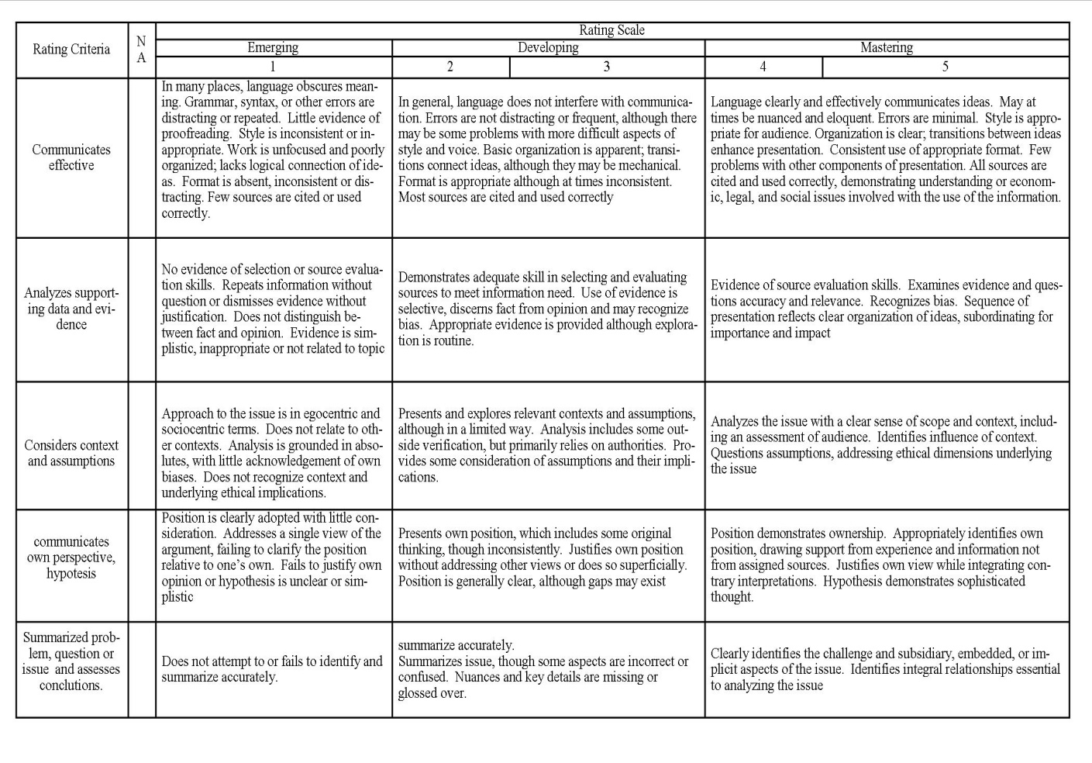

Above is scoring rubric for critical thinking which modified by the researcher. The researcher using number 1 to 5 for the score, and there are five rating criteria will be assess. And the following is the assessment of critical thinking.

Total score of rating Scale X 4 =
If debater has all the criteria with a value of 5 so that the value becomes 100 then, the researcher multiplies the total score of rating scale by 4. And the value can be seen in table 1.3
- Debate

- Definition of Debate
Debate is the discussion or exchange of opinion about a matter by giving each other alasa to defend their opinions - each.All speaking activities above encourage students to practice speaking in classroom.While according to expert A debate is a speaking situation in which opposite points of view are presented and argued (Dale& Wolf : 2000,p. 72 )
A debate is about the real or simulated issue. The learners’ roles ensure that they have adequate shared knowledge about the issue and different opinions or interest to defend. At the end of activity, they may have to reach a concrete decision or put the issue to a vote (Littlewood : 1981, p.72 ).
Based on definition above it can be concluded that the debate is an activity that involves between two camps of mutual disagreement and mutual defense of each. And at the end of the debate will be decided a decision that concrete.
Debate is one of technique which has many benefits for students :
- Improve students’ critical thinking. In debating, every student is proposed to analyze a problem critically
- Develop students’ communication skill. Debaters spend many hours assembling and practicing hundreds of public speeches on topics of national importance
- Questioning skill developed in and struggle often in the face of disappoinmentand defeat.
- They are capable of making and defending informed choices about complexissues outside of their own area of interest because they do on a daily basis.
- Debate is thus not only a way to connect students with academic subjects in meaningful ways, it is also a way to reconnect students to public life if they have been overcome by feelings of alienation.
- Policy debate specifically theaches students to adopt multiple perspectives which describe as one of the most important problemsolving skills ( Bellon : 2000, p. 73)

Methodology
The design of research which used by the researcher in this Research was Classroom Action Research (CAR). Classroom action research is an action research conducted by the teacher in the classroom. This data was analyzed through two cycles in action. The researcher conducted the classroom action research in Islamic University Of Assyafi’iyah, It was located in Jatiwaringin street. This research was involved thefirst Semester English Education Study Program was consist of 33 college students and they were as subjects of this research.
The technique and the method in this reasearch , the researcher used observation and test to collect the data. The researcher use the checklist observation to make it more systematic, containing list of students’ activities and response or happening which might happen. Observation was intended to see and to know about the condition of class and students. Process of teaching and learning through debate to know the obstacles appear during teaching learning process, the students’ motivation, to see their difficulties, their problem, and their understanding about the material given that can be seen from their attitude, behavior, and response.
In this research, the researcher got score from the two cycles conducted in the research. Mean of score first cycle was compared with mean of cycle two. It was to know how far the progress of students in this research. On the first cycle, the researcher gave an explanation of the debate ( what is a debate?, how to debate, technique and procedure of debate, case building of debate ) and students do the debate simulation for the first time, this is called the pretest. On cycle two, students conducted a debate for the final score, and as a result of the assessment of this research. This is called the post test.

Discussion
In this chapter the researcher will present the result of the research from cycle one and cycle two.The participants in this research are from 1st semester of the English language study program, Islamic university of Assyafi’iyah it consist of 33 students.
In this research was classroom action research, In this research the researcher using
debate technique to enhance student’s critical thinking. The process of research cab be seen in the table 1.2
Table 1.2 the process of the research
Cycle | Meetings | Activity
Cycle one Debate about :  - Animal testing should be banned  - Money bring more harm than good  - Allowed interfath marriage  - Take away obase children from their parents | - Friday, 28th of September 2018  - Monday, 01st of October 2018  - Tuesday, 02nd of October 2018 | - Introduction of debate, and the way to enhance critical thinking .  - Case building of debate and made a group for debate  - Practice debate  - Pre test
Cycle two Debate about :  - Abortion should be legalized  - Homework should be banned  - Prostitution should be localized  - Collage students should have part time jobs. | - Wednesday, 03rd of October 2018  - Thursday, 04th of October 2018  - Friday, 05th October of 2018 | - Practice debate  - Post test

In this research there were 3 meeting In each cycle.Thecycle consisted of four steps. They were plan, action, observed and reflect.The following was a brief explanation of the steps in cycle 1 :

Table 1.3 Cycle 1
Planning | Topic : Enhancing Critical Thinki1ng  Through debate  - Introduce of debate  - Practice debate to enhancing students critical thinking with the motion :  - Animal testing should be banned  - Money bring more harm than good  - Allowed interfath marriage  - Take away obase children from their parents
Action | First and second meeting  - Explain about intoduction of debate and ways to Enhance critical thinking  - Watching video of debate  - Case building  Third meeting  - Pre test
Observation | Students :  - Students pay attention to the teacher / researcher’s explanation carefully, even though there are some students who don’t pay too much attention.  Teacher :  - The Teacher explained the material louder and briefly (introduction of debate, ways to enhance critical thinking ).  - The teacher assesses the ongoing debate and record the shortage of students to be evaluated.  - The teacher becomes adjudicator during debate.  Classroom Situation :  - Students are very enthusiastic in participing debate for the first time. When they very excited, they made the class very crowded.
Reflection | Strenght :  - By debate technique, students can enhance their critical thinking and without realizing, debate can enhance student’s speaking skill.  Weaknesses :  - There are students still confused about debate and each task in debating
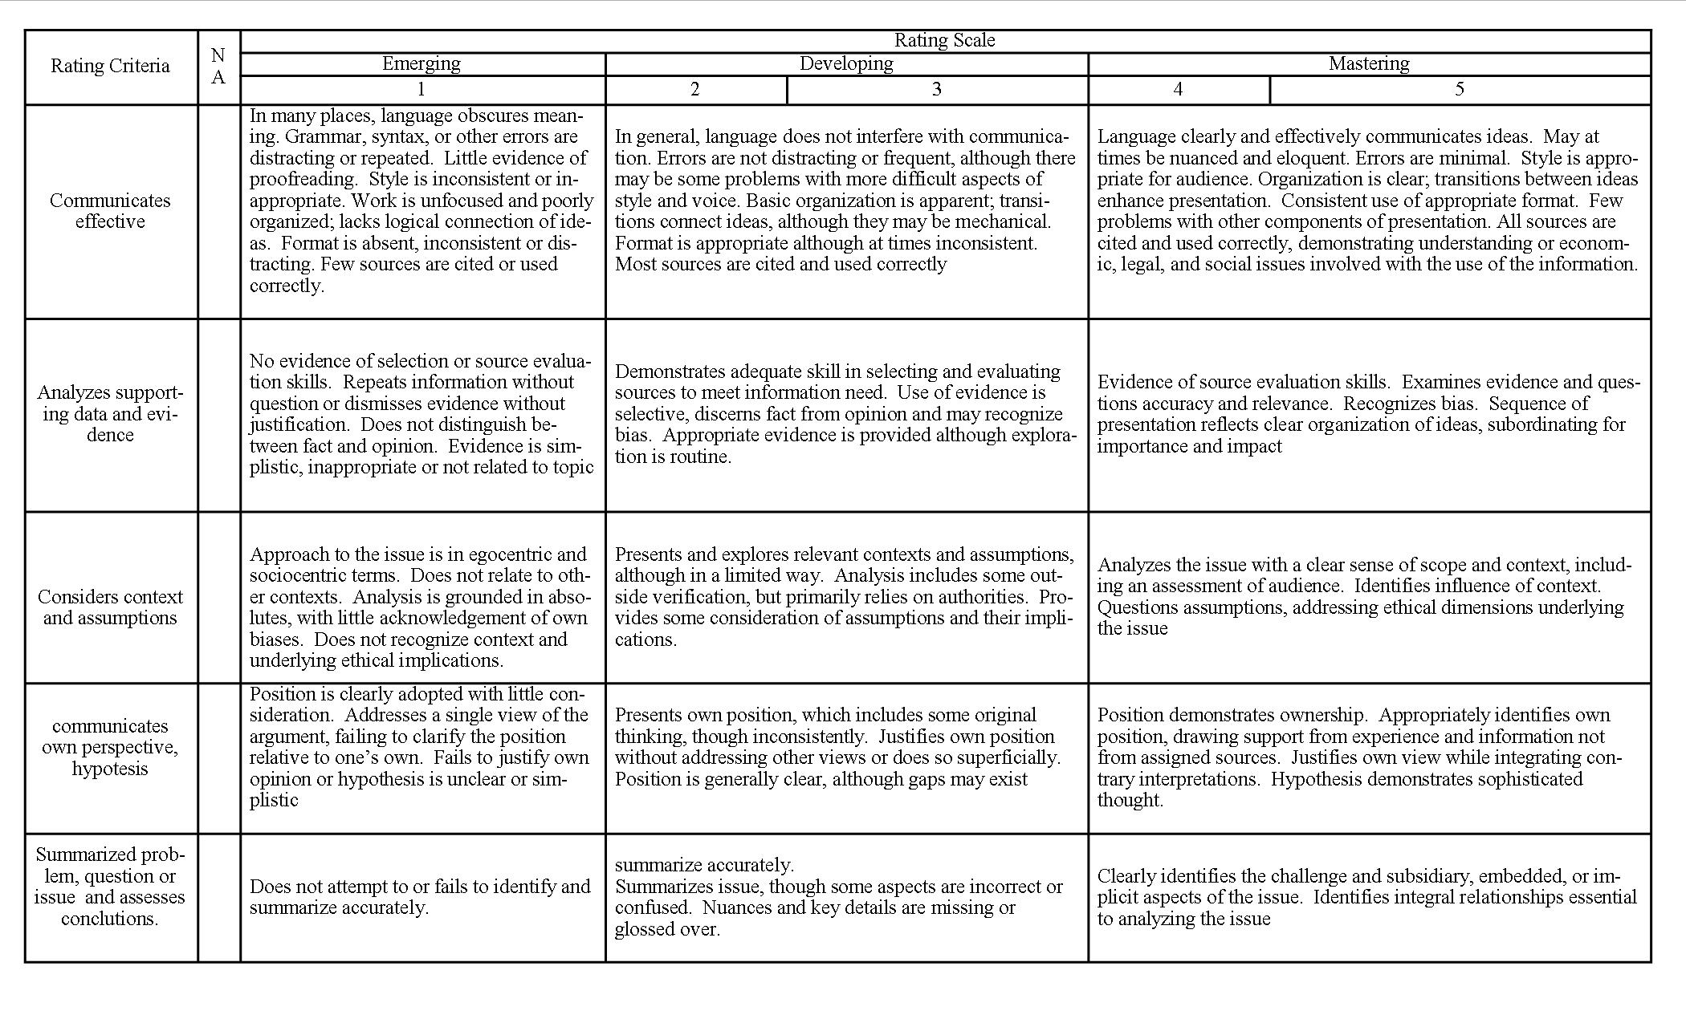
After conducted the pre- test in cycle one, the results of this study were 62.87. The details can be seen in table 1.4
Table 1.4 , the result of cycle one.
No. | Nama | Score  Cycle 1
1 | Tri setya ningsih | 60
2 | Pyapong | 68
3 | Siti rohmah | 60
4 | Irfan widadi | 68
5 | Nur hidayah | 68
6 | Fauzia amalia rahma | 72
7 | Jusmin bugis | 60
8 | Jirapat pethceun | 60
9 | Rezqia lidya pertiwi | 60
10 | Putri nabila | 60
11 | Nur Ayu fatimah | 60
12 | Marliana nabila | 60
13 | Dinda salma | 60
14 | Dyah eka putri | 60
15 | Isna namira | 80
16 | Chica ayu l | 60
17 | Siti hajar | 72
18 | Asmah senkhao | 60
19 | Faridatun hasanah | 60
20 | Sindy salsabila malik | 60
21 | Luthfia lubis | 60
22 | Jihan noviana iswara | 60
23 | Putri maulidina | 64
24 | Hani hastari | 60
25 | Nabila pri anggraini | 60
26 | Citra yunita | 60
27 | Lulu ani | 60
28 | Nita | 60
29 | Vina nur fadhilah | 60
30 | Della aprilia riqiani | 72
31 | Sinta julia pratiwi | 60
32 | Filza andiani | 60
33 | Maulana nur musa | 60
Total |  | 531
Average |  | 62,87

Because the value is insufficient,further research is needed, namely cycle two. In cycle two also consisted four steps like cycle one. The following was a brief explanation of the steps in cycle 2 :
Table 1.5 Cycle 2
Planning | Topic : Enhancing Critical Thinking Through  debate  - Practice debate to enhancing students critical thinking with the motion :  - Abortion should be legalized  - Homework should be banned  - Prostitution should be localized  - Collage students should have part time jobs.
Action | Fourth and five meeting  - Practice debate  Sixth meeting  - Post test
Observation | Students :  - Students begin to debate seriously and confidently  Teacher :  - The teacher assesses the ongoing debate and record the shortage of students to be evaluated.  - The teacher becomes adjudicator during debate  Classroom situation :  - Class is better than before  - Students who debate developing significantly both in terms of critical thinking or their attitude in debate
Reflection | Strenght :  - By debate technique, students can enhance their critical thinking and without realizing, debate can enhance student’s speaking skill.  Weaknesses :  - There are students still confused about debate and each task in debating

After conducted the post- test in cycle two, there are values improvement between cycle one and cycle two. The result in this cycle is 70,37. The details can be seen in table 1.6
Table 1.6 the result of cycle two
No. | Nama | Score  Cycle 2
1 | Tri setya ningsih | 72
2 | Pyapong | 80
3 | Siti rohmah | 64
4 | Irfan widadi | 80
5 | Nur hidayah | 76
6 | Fauzia amalia rahma | 88
7 | Jusmin bugis | 64
8 | Jirapat pethceun | 68
9 | Rezqia lidya pertiwi | 68
10 | Putri nabila | 68
11 | Nur Ayu fatimah | 64
12 | Marliana nabila | 68
13 | Dinda salma | 68
14 | Dyah eka putri | 68
15 | Isna namira | 88
16 | Chica ayu l | 68
17 | Siti hajar | 88
18 | Asmah senkhao | 64
19 | Faridatun hasanah | 64
20 | Sindy salsabila malik | 68
21 | Luthfia lubis | 68
22 | Jihan noviana iswara | 68
23 | Putri maulidina | 68
24 | Hani hastari | 68
25 | Nabila pri anggraini | 68
26 | Citra yunita | 64
27 | Lulu ani | 64
28 | Nita | 64
29 | Vina nur fadhilah | 64
30 | Della aprilia riqiani | 88
31 | Sinta julia pratiwi | 64
32 | Filza andiani | 68
33 | Maulana nur musa | 60
Total |  | 578
Average |  | 70,37

From the result of cycle one and cycle two, it can be seen that there is increase in value between cycle one and cycle two. For more details can be seen on the following chart.

In the cycle one when taking the value of critical thinking with the debate technique, the average result of 33 students was 62.87. This is a good start for beginners. Initially during the first meeting, students were still confused about the debate and how to debate. But, after practicing debate for the first time they felt interested because they were arguing each other.
in the cycle two, obtained a large average result 70.37. in this cycle students' critical thinking skills increase, and they already understand the debate. Students debate very enthusiastically, their critical thinking increases to criticize one argument with another. To get the value above the researcher uses rubric scoring from Center for Teaching, Learning, & Technology at Washington State University which was modified by the researcher to fit the required value.
Besides, we had also provided the scoring rubric categories seen in Table 1.1. Based on the result above, can be seen that scores of the student test, The average cycle one is 62,87 and cycle two is 70,37 this indicate there are enhancing critical thinking between cycle one and cycle two.

Conclusion
From the previous page regarding the enhancing of critical thinking through the debate technique conducted in the 1st semester of the English language study program, Islamic university of Assyafi’iyah it can be concluded that, debate techniques can be used to enhancing students' critical thinking, because in debate students are required to seek and provide arguments along with data regarding motions that obtained, and students also have to think of various reasons to bring down their interlocutors. And unconsciously this can increase students' knowledge. And can be seen from the average value between the first cycle which is 62.87 with an average value of the second cycle which is 70.37 there is a good increase.
Therefore debate is a method or technique that is suitable for increasing students 'critical thinking not only in debate, students' habit of critical thinking will automatically be used in various situations including problem solving and critical thinking that makes students can be open mainded and this will make students progress and developing.

References
Bellon, Joe, A. (2000). Research-based Justification for Debate across the Curriculum, Atlanta, Georgio State University: Vol 36.
Dale, Paulette and James C Wolf. (2000).Speech Communication Made Simple, 2nd Ed. NY: MiamiDade Community College
Ennis. 1985. Reasonable and reflective thinking, pp.45.
Johnson, Elaine B. 2010. Contextual Teaching and Learning: Menjadikan Kegiatan Belajar Mengajar Mengasyikkan dan Bermakna. Bandung: Kaifa.
Littlewood, 1981 in Arung, 2016. Improving the Students ` Speaking Skill through Debate Technique. Kolaka : Universitas Sembilan belas November Kolaka.
Mellshaliha.2008. Australasian English Debate Rules. Accessed on March 23rd, 2015.
Surya, Hendra. 2011. Strategi Jitu Mencapai Kesuksesan Belajar. Jakarta: Gramedia
Steinberg, R., 1985. Critical thinking: Its nature,. measurement and improvement. In R. L. Francis (Ed.)
https://www.mastah.org/ciri-ciri-dan-contoh-berpikir-kritis-pengertian-secara-umum/
https://collegeinfogeek.com/improve-critical-thinking-skills/

